Managing Shopify Markets in Klaviyo

Revision | Updated
1.0.0 | 05/12/2023
1.0.1 | 13/12/2023
1.0.2 | 14/12/2023

Background 2
What is a market? 2
Shopify Markets Integration Checklist 3
Profiles 4
Client Side Tracking of Market information 5
Server Side Tracking of Market Information 6
Order Created Trigger 6
Customer Created Trigger 7
Events 9
Viewed Product 9
Added to Cart 10
Flows 11
Approach 1 - Multiple Flows - 1 Flow per Language/Market/Currency 11
Approach 2 - Single Flow - Multiple Splits 13
Approach 3- Single Flow - Dynamic Content 14
Segments 16
Campaigns 17
Approach 1 - One Email Template sent to one list/segment 17
Approach 2 - One Email Template sent to multiple lists/segments 18
Approach 3 - Separate Email Template and Campaigns 19
Templates 21
Shopify Event Data 21
Referencing Market Profile Data in Templates 23
Catalogs 25
Generating Product Feeds 26
Approach 1 - Generating Product Feeds in Shopify 28
Approach 2 - Other Ways of Generating Feeds 32
Using Shopify Market Catalog Data in Email Templates 33
Product Availability 34
Product Recommendations 35
Back in Stock Notifications 36
One inventory shared across all markets 36
Different Inventory Per Market 36
Price drop Notifications 37
Managing Consent 38
Shopify List Sync 38
Two-Way Klaviyo Sync 39
Unsubscribe and Preference Pages 39
Double Opt In 40
Signup Forms 40
Reporting 42
Migrating From Multiple Shopify Accounts to a Single Shopify Markets enabled account 44
Migrating Order Data 44
Migrating Profiles 45
Migrating Engagement Data 45
Migrate Suppressions 46
Migrating any other events 47
Migrating Flows 47
Sending Domains and Deliverability 48
Sending domain 48
IP Address and IP Pools 48
Splitting Shopify Markets into separate Klaviyo Accounts 49
Backfilling Shopify Markets Profile information 50
Common Integration Scenarios 52

Background
The purpose of this doc is to act as a master guide of all the various things that need to be considered when integrating Klaviyo with a Shopify Markets enabled store.

Traditionally, customers would have a separate Shopify Store per market, which resulted in one Klaviyo account integrated per market.

With Shopify Markets, only one Klaviyo account can be integrated via the standard Klaviyo integration because our integration is 1:1 and all of the markets are hosted in a single Shopify Store.
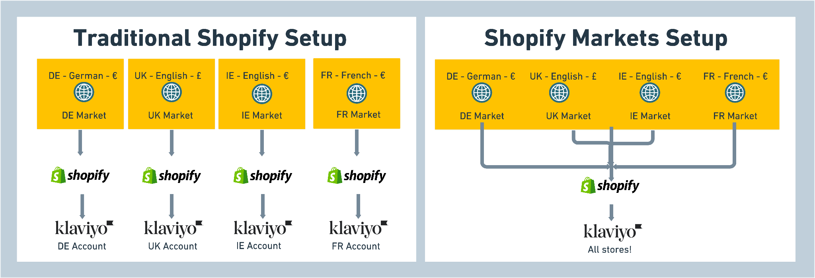

What is a market?
A market is a country or group of countries that can be defined into a “market” in Shopify. Each market shares its products and pricing structure.

A market can consist of different currencies and languages. ie. A Belgian market could be available in English, Dutch, German and French.

Shopify Markets Integration Checklist
Below is a checklist of each component in your Klaviyo account that may be affected by your Shopify Markets integration. Use this checklist to ensure you have covered everything, and reference the content further in this document for each point as needed.

- Add Client Side tracking of market specific profile properties
- Add Server Side tracking of market specific profile properties
- Check Viewed Product and Added to Cart Scripts
- Configure flows, splits and content to use market properties
- Reference “Presentment Currency” in metric triggered flows
- Create segments of market profiles
- Decide on product catalog approach
- Create localised custom product blocks
- Check and make modifications for Back in Stock flows
- Check and make modifications for Price Drop flows
- Confirm consent options
- Create multilingual unsubscribe and preference pages
- Configure sign up forms per market/language
- Check compatibility of extra integrations

Profiles
Profiles will be shared across all markets, and will only exist in Klaviyo once.

A profile can switch between markets, and could make purchases in multiple markets.

A profile can choose their language, market and country usually via a popup dialog like below, or they will often be automatically redirected.
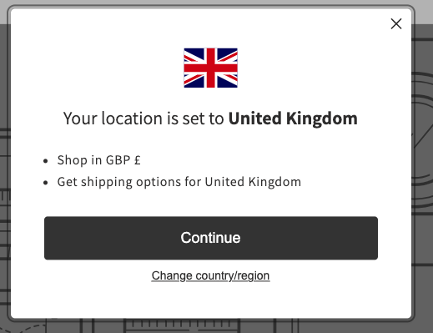

It is recommended to store these locale/language/market/currency settings as a profile property in Klaviyo.

Client Side Tracking of Market information
This can be done by adding the below snippet to the main theme.liquid file. This will automatically add the information for any profile identified by Klaviyo

 <script>
var klaviyo = klaviyo || [];
klaviyo.push(['identify', {
{% if customer.email %}
'$email': '{{customer.email}}',
{% endif %}
'shopify_locale': '{{ request.locale.iso_code }}-{{localization.country.iso_code}}',
'shopify_language': '{{ request.locale.iso_code }}',
'shopify_country': '{{ localization.country.iso_code }}',
'shopify_currency_code': '{{ localization.country.currency.iso_code }}',
}]);
</script>


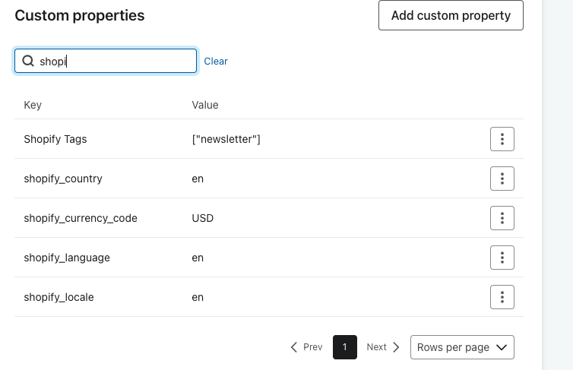

Server Side Tracking of Market Information

Order Created Trigger
For profiles who place an order and are not identified by Klaviyo, we can still record the relevant market information. This can be done using a Shopify Flow.
Setting up a flow like this will automatically record a “Updated Locale” event each time the customer places an order. It will update the profile properties, and keep a log of the changes in the event.
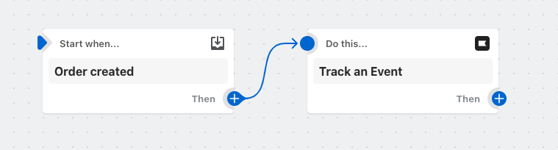

For ease, this flow template can be downloaded and imported into your account. You then need to configure the “Track an Event” activity to have the accounts Public Key (see [ENTER_PUBLIC_KEY])

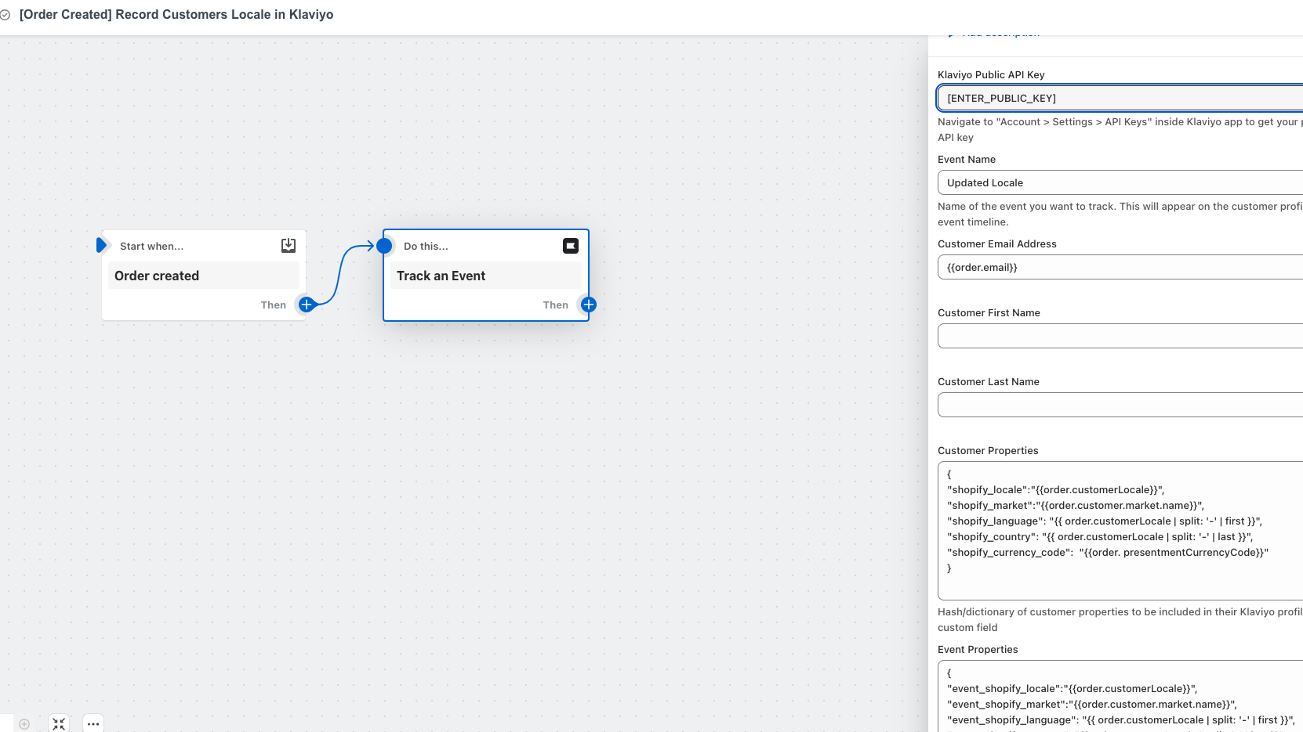

Customer Created Trigger
There are other scenarios where a customer could be created in Shopify, and not necessarily place an order. This happens when a user starts a checkout and abandons. After ~10 minutes a customer will be created in Shopify.

This trigger will also cover if a user has just registered on a Shopify store, but not purchased.
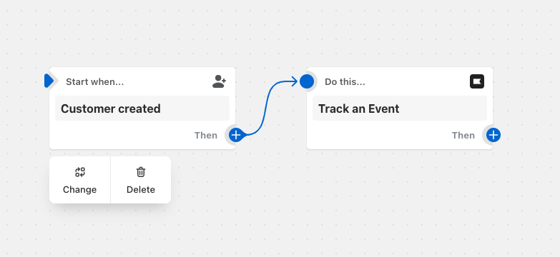

Download Template

Manual Steps
If you prefer to create this flow manually:

- Create a new Flow in Shopify, with a trigger of “Order Created”
- Add a “Track an Event” activity (this is part of the Klaviyo x Shopify integration)
- Populate the Public API Key, Event Name, Email Address and the customer/event properties.
Customer Properties

{
"shopify_locale":"{{order.customerLocale}}",
"shopify_language": "{{ order.customerLocale | split: '-' | first }}",
"shopify_country": "{{ order.customerLocale | split: '-' | last }}",
"shopify_currency_code": "{{order. presentmentCurrencyCode}}"
}


Event Properties

{
"event_shopify_locale":"{{order.customerLocale}}",
"event_shopify_language": "{{ order.customerLocale | split: '-' | first }}",
"event_shopify_country": "{{ order.customerLocale | split: '-' | last }}",
"event_shopify_currency_code": "{{order.presentmentCurrencyCode}}"
}


Once configured, you will see events and profile properties like below in your Klaviyo account
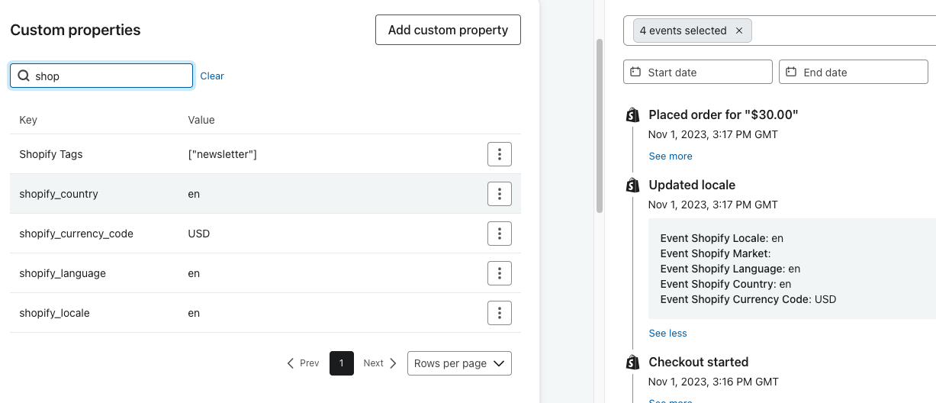

Flows
Once you have started capturing the relevant Shopify Market information, you can start to use this to personalise the content in your Flows.

You have several options for how you wish to manage your flow structure, each has its own set of pros and cons.

Approach 1 - Multiple Flows - 1 Flow per Language/Market/Currency
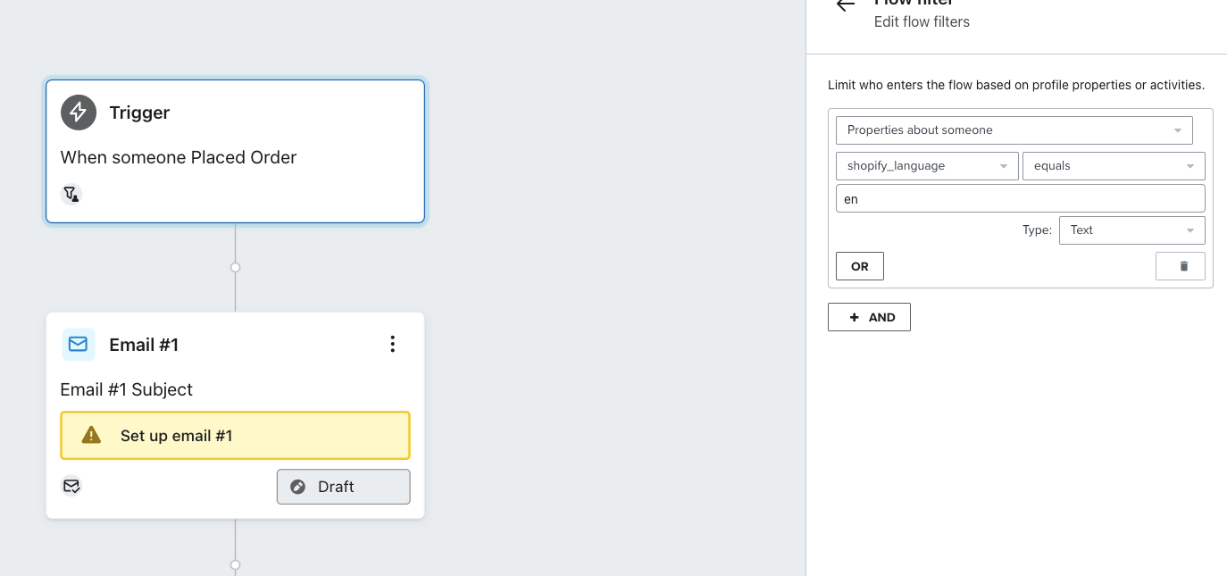

If your flow is triggered by the metric “Checkout Started” ensure you have a wait activity before the first email is sent, as it can take Shopify 10 - 15 minutes before the customer is created and the market properties set.

Top Tip: Make sure to use a consistent naming structure to help you quickly identify your market. Also make use of Tags for grouping of reports

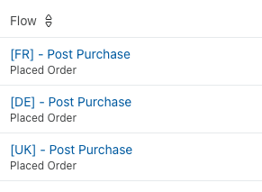
Pros:
- Easy to differentiate the content per market
- You can have completely different flows per market
- Clear overview of performance per market
Cons:
- Multiple flows to manage and maintain
- Duplication of work
- Custom report needed to get overall flow performance

Approach 2 - Single Flow - Multiple Splits
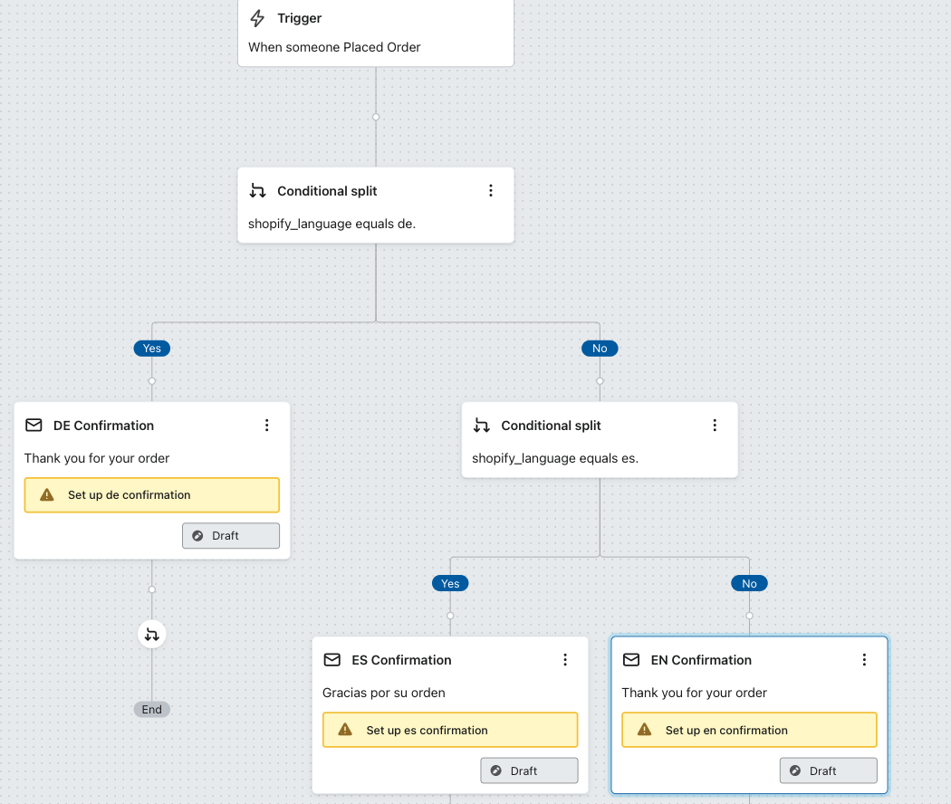
Top Tip: Make your default fallback split be the email in your primary language, that way even if you add more markets/languages in future, you will always have a fallback email.

Pros:
- Easy to differentiate the content per market/language
- You can have separate branches per market/language
- You can see individual email performance per market
- You will get overall flow performance

Cons:
- Multiple branches to maintain
- Some duplication of email work
- You will need a custom report to get flow performance by market

Approach 3- Single Flow - Dynamic Content

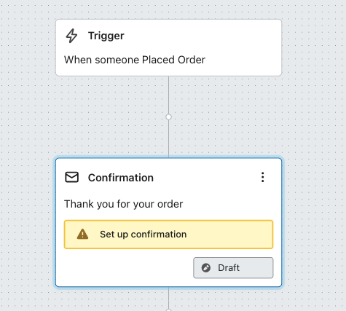

All the logic will sit inside the email template. You can use dynamic content to determine which blocks will appear in the email
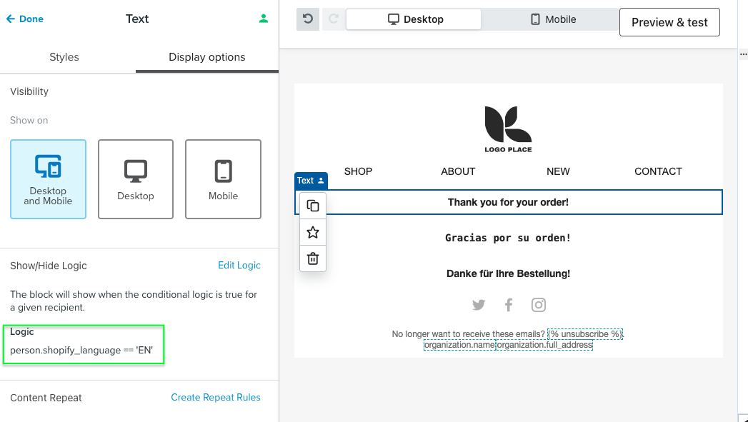

Pro Tip: You can manage all of this dynamic content externally via a Spreadsheet
https://medium.com/klaviyo-developers/solution-recipe-1-use-google-sheets-as-a-dynamic-content-source-c7028fbf22ba

https://www.loom.com/share/ace3fe9e2214478c8a9ba38dd1bceebd
https://www.loom.com/share/5caaba4c9e674000bc8f6854bbf27799

Pros:
- Minimal number of flows to maintain
- All logic and email content is in 1 place
- 1 overall report

Cons:
- More testing and logic needed in emails
- Challenging to personalise all parts of the email (ie. subject line)
- Reporting cannot be broken down by market

Segments
Once the profile properties have been added, it is relatively straightforward to segment profiles based on their Shopify Market. Any of the language, locale, market, country or currency properties can be used.

It is up to you and your use case to determine which of these properties you want to use. A single Shopify market could have multiple different languages configured. For example if you have a Belgium market, you could have English, French, German and Dutch configured as languages.

Or you could have just a single EU market with multiple different languages configured. Every customer will have their own unique setup.
https://help.shopify.com/en/manual/markets/managing-markets

Example segment of German 1 time purchasers
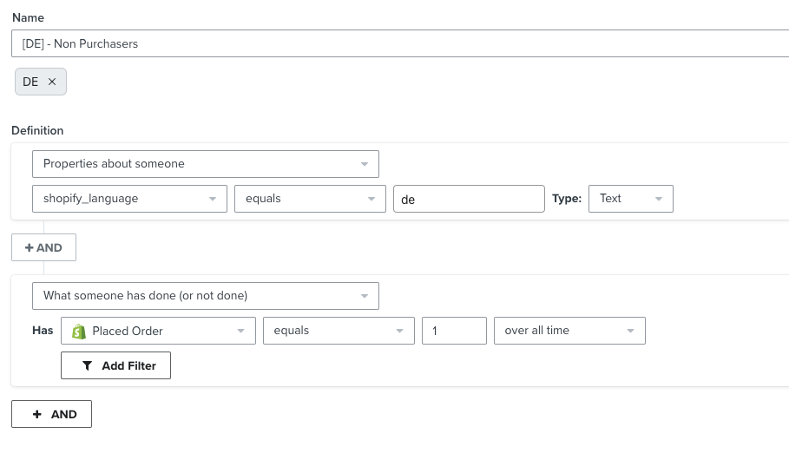

Top Tip: Make use of the Tags feature so you can easily group together segments per market. A good naming convention is also helpful for organisation.

Campaigns
When sending campaigns, there are three approaches that you can take.

Approach 1 - One Email Template sent to one list/segment
In this scenario, you would build your email template with dynamic content like below

And have just a single campaign to send

Pros:
- Easy to differentiate the content per market/language
- You only need to build 1 email template
- 1 general report on email performance

Cons:
- Additional logic to build, maintain and test
- You do not get a breakdown of reports per market
- Support for dynamic subject lines can be limited

Approach 2 - One Email Template sent to multiple lists/segments
In this scenario, you would build your email template with dynamic content like below

However, when you are sending the email, you would ensure that you include multiple different segments. Each segment should represent your market. This way you will get access to email campaign performance broken down by segment
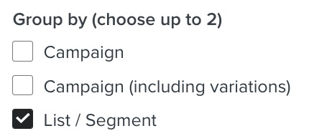
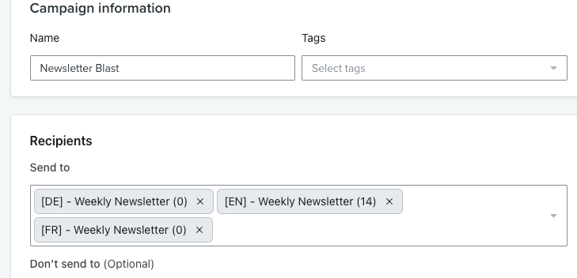
Pros:
- Easy to differentiate the content per market/language
- You only need to build 1 email template
- 1 general report on email performance
- Ability to break down email performance by segment

Cons:
- Additional logic to build, maintain and test
- Additional segments to create
- Support for dynamic subject lines can be limited

Pro Tip: You can manage all of this dynamic content externally via a Spreadsheet
https://medium.com/klaviyo-developers/solution-recipe-1-use-google-sheets-as-a-dynamic-content-source-c7028fbf22ba

Approach 3 - Separate Email Template and Campaigns
In this scenario, you would have a unique or dynamic email template that you clone and use across multiple different campaigns. You would send a campaign for each market/language that you want, using segments/lists to identify your audience.

Pros:
- Easy to differentiate the content per market/language
- You will get more granular reporting per market/language
- Simplified email build

Cons:
- Additional email templates to build
- Additional time to create campaigns and segments

Templates

Shopify Event Data
The default email templates that Klaviyo sets up as part of the pre-built flow library will automatically reference the base markets language and currency.

The events coming from Shopify include the base market and also the market the customer was using at the time. You will need to update the relevant parts of your template to reference the market event data as appropriate.

For example, if you look at the Shopify Placed Order metric, you will see there are always two different values for currency.

“shop_money” and “presentment_money”
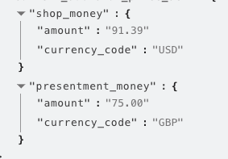

{{ event.extra.total_price_set.presentment_money.amount }}
{{ event.extra.total_price_set.presentment_money.currency_code }}


The “presentment_money” field is the currency the customer actually saw and used on your website, so it makes sense to show this information in the email.

Unfortunately, Shopify shares the currency code, but not the currency symbol with us. In most scenarios you will want to display the currency symbol in the email, not the code (i.e € not EUR)

The below code snippet will automatically find the correct currency symbol to go with the relevant currency code. It can be modified to include additional currency symbols.

 {% with eventCode=event.extra.total_price_set.presentment_money.currency_code %}
{% with currency_codes="EUR-&euro;,USD-$,GBP-&pound;"|split:',' %}
{% for code in currency_codes %}
{% if eventCode in code %}{{ code|split:'-'|lookup:1|safe }}{{ event.extra.total_price_set.presentment_money.amount }}{% endif %}
{% endfor %}
{% endwith %}
{% endwith %}


You will also see a “customer_locale” property in the event which can be referenced if needed, though you will also have this information stored as a profile property if you followed the steps outlined earlier
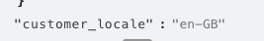

{{ event.extra.customer_locale }}

If you have translated your products correctly, you should also see “presentment_title” on the line items in your products too.
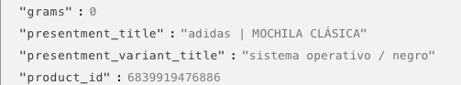

{{ event.extra.line_items.0.presentment_title }}


Referencing Market Profile Data in Templates
If you have added the relevant code snippets to record Shopify Market data on the profile, you should have the below information on your profiles in Klaviyo.

You can reference any of this data with the following syntax
{{ person.[property_name] }}

For example, {{ person.shopify_language }}

You can use this as dynamic content directly in the template editor with our django code

{% if person.shopify_language == 'de' %}
Vielen Dank für Ihre Bestellung
{% elif person.shopify_language == 'fr' %}
Nous vous remercions de votre commande
{% else %}
Thank you for your order!
{% endif %}

Or by using the dynamic content blocks

Catalogs
In Shopify Markets, users have the option to configure different prices, products, inventory and descriptions per market.

The Klaviyo x Shopify integration will continue to sync the product catalogue, however it will only synchronise the properties related to the primary market for that store.

Products are translated using Shopify's Translate & Adapt app
https://help.shopify.com/en/manual/markets/languages

In this screenshot, the primary market is US, so all products will be in English and prices will be in USD
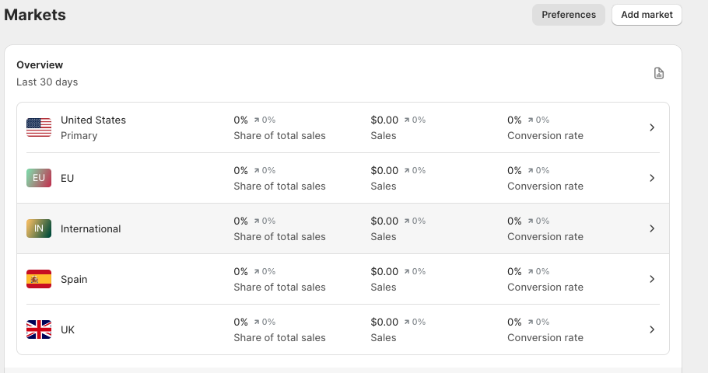

If you wish to support products with multiple languages/prices then you will need to add a custom catalog to your Klaviyo account via a Feed or API
Sync a custom catalog feed to Klaviyo

💡Product Catalog Explainer
The product catalog in Klaviyo is only needed for Price Drop, Back in Stock Alerts, Product Recommendations and the drag/drop email template product block. All product information is sent to Klaviyo in events from Shopify, so adding a custom catalog is not required for event driven flows (ie. Abandoned Checkout, Post Purchase)

Generating Product Feeds
The structure of this catalog feed is important. The main challenge is Klaviyo only supports 1 instance of a product ID in a custom catalog feed. Klaviyo will automatically deduplicate products when multiple product IDs are detected

The general structure we recommend Shopify Market customers use is to following an ID naming convention like this
- {product_id}_{locale}
- KLAVIYO-TSHIRT1_en-US
- KLAVIYO-TSHIRT1_en-GB
- KLAVIYO-TSHIRT1_de-DE
- Etc..

Note: You do not have to append locale, it might make more sense for you to just append language or the country. This will depend on if your prices vary by market etc..

[
{
"id":"KLAVIYO-TSHIRT1_en-US",
"title":"Classic Klaviyo T-Shirt 1",
"link":"https://klaviyogear_US.myshopify.com/collections/klaviyo-classics/products/short-sleeve-t-shirt-1",
"description":"Standard issue for all Klaviyos. This t-shirt has the Klaviyo logo on the front and mark diagram on the back.",
"price":20,
"currency": "USD",
"image_link":"https://www.klaviyo.com/media/images/examples/products/klaviyo-tshirt-thumbnail.png",
"categories":["apparel","t-shirt","new-arrival","swag"],
"inventory_quantity":190,
"inventory_policy":1
},
{
"id":"KLAVIYO-TSHIRT1_en-UK",
"title":"Classic Klaviyo T-Shirt 1",
"link":"https://klaviyogear_UK.myshopify.com/collections/klaviyo-classics/products/short-sleeve-t-shirt-1",
"description":"Standard issue for all Klaviyos. This t-shirt has the Klaviyo logo on the front and mark diagram on the back.",
"price":15,
"currency": "GBP",
"image_link":"https://www.klaviyo.com/media/images/examples/products/klaviyo-tshirt-thumbnail.png",
"categories":["apparel","t-shirt","new-arrival","swag"],
"inventory_quantity":70,
"inventory_policy":1
},
{
"id":"KLAVIYO-TSHIRT1_de-DE",
"title":"Klassisches Klaviyo-T-Shirt 1",
"link":"https://klaviyogear_DE.myshopify.com/collections/klaviyo-classics/products/short-sleeve-t-shirt-1",
"description":"Standardausgabe für alle Klaviyos. Dieses T-Shirt hat das Klaviyo-Logo auf der Vorderseite und ein Markendiagramm auf der Rückseite.",
"price":18,
"currency": "EUR",
"image_link":"https://www.klaviyo.com/media/images/examples/products/klaviyo-tshirt-thumbnail.png",
"categories":["apparel","t-shirt","new-arrival","swag"],
"inventory_quantity":30,
"inventory_policy":1
}
]


Depending on the solution you choose, you may also need to build custom product blocks to dynamically reference products from the relevant market.

Keep in mind, you generally only need a product feed for “Parent” products and not all the variants. Klaviyo uses the Parent product for product recommendations.

Approach 1 - Generating Product Feeds in Shopify
One approach for generating product feeds in Shopify is to leverage a template in Shopify to create the feed for you.

You can create a special template in Shopify which will give us the feed we need for your products, and it will automatically translate and localise them for you.

- Login to your Shopify admin
- Edit the code for your current theme
- Add a new Template like the screenshot below and save it
- Now exit the theme editor and create a new Page
- Call the page something like "Product Feed" and set the theme template to be the new "product_feed" one you just created
- Now publish and view the page, and hopefully it will generate a product catalog for you
- If you change the URL of this feed to include the different locales, you should find it changes language automatically
- {{your_store}}/en-es/pages/{{page_name}}

Pro Tip: If you have more than 1000 products in your catalog, you will need to paginate this catalog by appending ?page=2 etc.. in the URL. These can be added as separate catalog feeds in Klaviyo which will be joined together automatically.

You can then add each of these feeds to your Klaviyo account as a custom catalog, and use them in the template builder
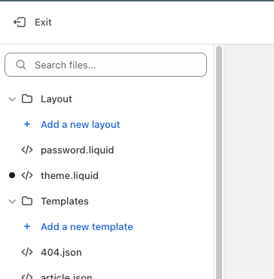
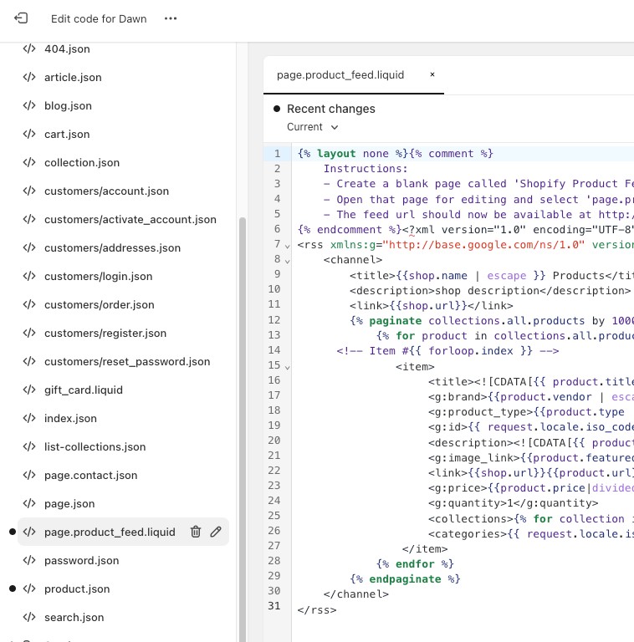

{% layout none %}{% comment %}
Instructions:
- Create a blank page called 'Shopify Product Feed'and save it
- Open that page for editing and select 'page.product-feed' from the page template selector
- The feed url should now be available at http://www.yoursite.com/pages/shopify-product-feed
{% endcomment %}{%- layout none -%}<?xml version="1.0" encoding="UTF-8" ?>
<rss xmlns:g="http://base.google.com/ns/1.0" version="2.0">
<channel>
<title>{{shop.name | escape }} Products</title>
<description>shop description</description>
<link>{{shop.url}}</link>
{% paginate collections.all.products by 1000 %}
{% for product in collections.all.products %}
<!-- Item #{{ forloop.index }} -->
<item>
<title><![CDATA[{{ product.title | strip_html | strip_newlines | escape | replace: 'amp;', 'and' | replace: '&#38;', 'and' | replace: "Ã©", "e" | replace: "Ã ", "a" }}]]></title>
<g:brand>{{product.vendor | escape }}</g:brand>
<g:product_type>{{product.type | escape }}</g:product_type>
<g:id>{{ request.locale.iso_code }}_{{product.id}}</g:id>
<description><![CDATA[{{ product.description | strip_html | strip_newlines | replace: 'amp;', 'and' | replace: '&#38;', 'and' | replace: "..", ". " | replace: " ", " " | replace: "â€˜", "&#39;" | replace: "â€™", "&#39;" | replace: "&#8216;", "&#39;" | replace: "&#8217;", "&#39;" | replace: "&#8217;", "&#39;" | replace: "Ã¢â‚¬â„¢", "&#39;" | replace: "Ã¢â‚¬Å“", "&#39;" | replace: "Ã¢â‚¬Ëœ", "&#39;" | replace: "Ã‚Â´", "&#39;" | replace: "â€œ", "&#34;" | replace: "â€", "&#34;" | replace: "&#8211;", "-" | replace: "Ã¢â‚¬â€œ", "-" | replace: "Ã¢â‚¬â€", "-" | replace: "â€“", "&mdash;" | replace: "â€”", "&mdash;" | replace: "%", "&#37;" | replace: "Ã‚Â©", "&copy;" | replace: "Ã‚Â®", "&reg;" | replace: "Ã¢â€žÂ¢", "&trade;" | replace: "Ã‚Â£", "&pound;" | replace: "Ã¯Â¿Â­", "&#42;" | replace: "Ã¢â‚¬Â¢", "&#42;" | replace: "Ã¢â‚¬Â", "&#39;" | replace: "&#233;", "e" | replace: "Ã©", "e" | replace: "Ã ", "a" | replace: "Ã³", "o" | replace: "Ãª", "e" | replace: "ÃƒËœ", "O" | replace: "&#8482;", "" | replace: "&#174;", "" }}]]></description>
<g:image_link>{{product.featured_image | product_img_url: 'large'}}</g:image_link>
<link>{{shop.url}}{{product.url}}</link>
<g:price>{{product.price|divided_by:'100.00'}}</g:price>
<g:quantity>1</g:quantity>
<collections>{% for collection in product.collections %}{{ collection.title }}{% unless forloop.last %},{% endunless -%}{% endfor %}</collections>
<categories>{{ request.locale.iso_code }}</categories>
<currency_code>{{ localization.country.currency.symbol }}</currency_code>
</item>
{% endfor %}
{% endpaginate %}
</channel>
</rss>



Approach 2 - Other Ways of Generating Feeds
There are a variety of tools and apps to generate product feeds in Shopify. If you have a particularly large Shopify catalog (more than a few thousand products) - then you will likely need to use a third party app to generate a feed.

One popular tool is Multifeeds https://apps.shopify.com/multiple-google-shopping-feeds

Many companies also use a service like Feedonomics https://feedonomics.com/supported-ecommerce-platforms/shopify/

The structure of the feeds should still follow the approach described above.

Using Shopify Market Catalog Data in Email Templates
After you have created your custom catalog and have your product data in Klaviyo, let’s look at how you can use that information in your email templates.

By default, the Klaviyo product blocks will only reference the data in the standard “Title”, “Price”, “URL” and “Image” fields. Data in any other fields needs to be referenced with a catalog lookup tag. Catalog lookup tag reference

Exactly how you look up the product catalog will vary depending on the approach you took with creating your custom catalog.

For example, if you append your locale to all of your product IDs, the below syntax would work for you. In this example the Product ID is “KLAVIYO-TSHIRT1_de-DE”

{% catalog "KLAVIYO-TSHIRT1_de-DE" integration="api" %}
{{ catalog_item.title }}
{% currency_format catalog_item.metadata|lookup:"$price" %}
{% endcatalog %}

Pro tip: You can manually specify which catalog you are looking up (Shopify or Custom) by using the integration flag. For example {% catalog ‘KLAVIY-TSHIRT1’ integration='api' %}

Here’s an example of dynamically looking up the catalog based on a profile property


{% with product_id='123' locale=person|lookup:'shopify_locale'|default:'en-GB' %}
{% catalog product_id|add:'_'|add:locale integration="api" %}
{{ catalog_item.title }}
{% currency_format catalog_item.metadata|lookup:"$price" %}
{% endcatalog %}
{% endwith %}


Product Availability
When using a single product model for the catalog, the localised data now sits within this single product, therefore, we can no longer use the inventory to manage availability between regions, as we could in the first example.

However, it is still possible to filter out products from recommendations by utilising Klaviyo categories. Categories can be filtered to create a product feed that belongs to that category to allow product filtering within campaigns.

How does this relate to localisation?

If we treat categories as ‘tags’, this changes the possibilities of how you can use product feeds. Simply by adding an availability tag such as available_gb to a product, this can then be added as a filter to a product feed to only display products that are available in GB.
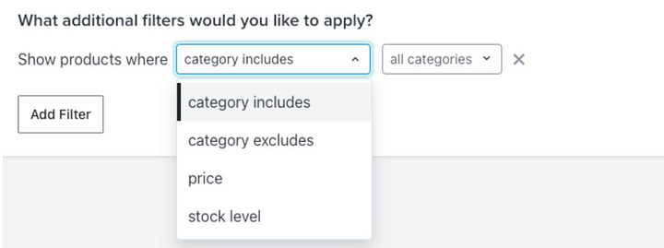

Product Recommendations
In order to make use of Klaviyo’s product recommendations and to use localised product information in your emails, you will need to build custom product blocks.

These product blocks reference the product information from your custom catalog, and use that Custom Catalog lookup tag mentioned previously.

We have an in-depth guide on setting up these recommendation blocks here
https://medium.com/klaviyo-developers/simplified-custom-product-blocks-b22e53d21bf6

At a high level, you can still create Klaviyo Product Recommendation Feeds as normal, but you will need to use a custom product block to display the localised version of these products. All of this is explained in the guide.

Note: Product recommendations will not be market specific as the same engagement data from all markets is used to power the recommendations algorithm.

Back in Stock Notifications

One inventory shared across all markets
If all of your markets are working from 1 inventory source and share an inventory, then you can continue to use the standard Shopify catalog for signing up customers to back in stock notifications.

However, due to a nuance with how Shopify Markets presents the product pages, you cannot use the out of the box Klaviyo back in stock script. You will need to add your own back in stock script using our API
https://developers.klaviyo.com/en/docs/how_to_set_up_custom_back_in_stock

This is a known issue which should be addressed in future updates

You can then use the catalog look tag in the back in stock notification emails to find the relevant localized content for the product alert.

{% catalog event.ProductId integration='api' %} {{ catalog_item.title }} {% endcatalog %}



Different Inventory Per Market
If some or each of your markets have a different inventory model, you cannot rely on using the Shopify product catalog as a trigger for a back in stock flow.

The best solution is to have separate items per market in your custom catalog, and subscribe profiles to back in stock alerts to these “ghost” products which are used for Back in Stock alerts
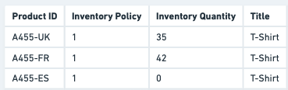

Price drop Notifications
Klaviyo will automatically detect price drop changes from the Shopify catalog, but these prices will all be the base market prices.

If prices are adjusted across all markets, you can perform a catalogue lookup to the relevant market in the custom catalogue to get to correct pricing information.

The below example will look up the catalog item relevant for this persons profile based on the shopify_locale property, and will default to en-GB if the profile property is not found.


{% with product_id=event.product_id locale=person|lookup:'shopify_locale'|default:'en-GB' %}
{% catalog product_id|add:'_'|add:locale integration="api" %}
{{ catalog_item.title }}
{% currency_format catalog_item.metadata|lookup:"$price" %}
{% endcatalog %}
{% endwith %}

If prices drops will not all occur at the same time across markets, you will need to perform a manual check inside the email template to see if the market specific price has actually dropped, and abort the email send if it has

You can abort an email send with the django snippet

{% catalog ABORT_SEND %} {% endcatalog %}

In order for this to work, you will need to store both price and sale_price as two separate columns in your custom catalogue

{% with product_id=event.product_id locale=person|lookup:'shopify_locale'|default:'en-GB' %}
{% catalog product_id|add:'_'|add:locale integration='api' %}
{% with price=catalog_item.metadata|lookup:"$price" sale_price=catalog_item.metadata|lookup:"sale_price" %}
{% if sale_price < price %}
//send email
{% else %}
{% catalog ABORT_SEND %} {% endcatalog %}
{% endif %}
{% endwith %}
{% endcatalog %}
{% endwith %}


Managing Consent
Shopify captures consent not per market but across the entire account. This means, when you integrate Klaviyo x Shopify, all consent will be synced to the one list in your Klaviyo account.

While it is possible to differentiate profiles based on their market locale properties, the opt in settings are configured on the list level. This means the list opt in settings will apply to all markets. For example, if you configure your list to be a double opt in list, it will apply to all profiles synced from Shopify.

Shopify List Sync
Option 1) Enable double opt in for all users (this would simply involve changing the list opt in setting)

Option 2) Single opt in for all users, but build a middleware to trigger a Double Opt In for German customers.
This process would look like
- All users synced to "List A - single opt in"
- Conditional logic in a flow triggers a webhook to some middleware (like Napkin.io) to subscribe the German profiles to a double opt in list "List B - double opt in"
- There would also need to be a profile property that gets updated by list membership to record if they accepted the double opt in, this would let you create your segments accurately later on.
Option 3) You "fake" a double opt in process
This process would look like
- All users synced to "List A - single opt in"
- A flow triggered by List A , An update profile property activity is setting "Opted In = True" for non German people, and "Opted In = Pending" for German people
- This then sends an email for the German profiles with a link to "Confirm your subscription", this uses a Klaviyo Update Profile Property link which changes the property "Opted In = True" when clicked
You can then segment by saying "Anyone who is subscribed to List A and Opted in = True"

Option 4) There is a company called Dataships.io which actually is built to handle capturing marketing consent differently by country on Shopify. Unfortunately it does come with an additional cost but is integrated with Klaviyo and Shopify for both email and SMS consent.

Option 5) Don't use the Klaviyo Checkout sync at all, and instead use the Shopify Webhooks for when a customer is created/updated and check if they have email consent
https://shopify.dev/docs/api/admin-rest/2023-04/resources/customer

Then use the country to determine which list to subscribe to in Klaviyo (a single or double opt in one). This would need to be performed in some middleware (like Napkin.io) . You would disable the checkout sync in your Klaviyo Shopify settings

Two-Way Klaviyo Sync
Klaviyo will sync opt in consent from Shopify to Klaviyo

If a profile unsubscribes in Shopify, that will not be reflected in Klaviyo

If a profile unsubscribes in Klaviyo, that will be reflected on their profile in Shopify.

Unsubscribe and Preference Pages
Unsubscribe and preference pages are by default configured at a global level in Klaviyo. All profiles will see the same standard pages, regardless of their language.

Klaviyo supports customising the unsubscribe and preference pages by list, so if you are using multiple lists to manage your markets you could configure a separate unsubscribe/preference page in the relevant language for each list.

Due to the default setup with the Shopify integration and Klaviyo lists, you likely just have one list configured in your account. You can use the hosted pages feature to custom code a dynamic unsubscribe and preference page which will support multiple languages.

There is guide on how to do that here
https://medium.com/klaviyo-developers/solution-recipe-8-how-to-create-a-custom-multilingual-unsubscribe-and-preference-page-in-klaviyo-310137154469

Double Opt In
Similar to the preference pages, double opt-in emails are configured on the list level. If only one list is being used, it is not possible to add dynamic content to automatically translate the double opt-in email. We recommend including multiple languages in your message if required.

Signup Forms
When using Shopify Markets, your store will generally follow a locale directory URL structure such as
https://mywebsite.com/en/
https://mywebsite.com/fr/
Using this URL structure, you can target Klaviyo Signup forms for the relevant market/locale as needed

Below is an example of targeting users on the French version of your site
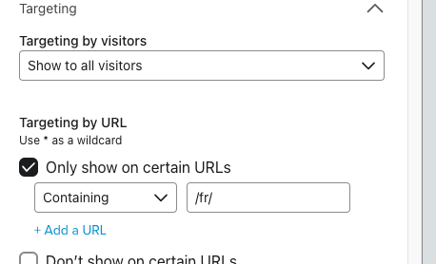

You can also customise the name and validation messages on the input fields
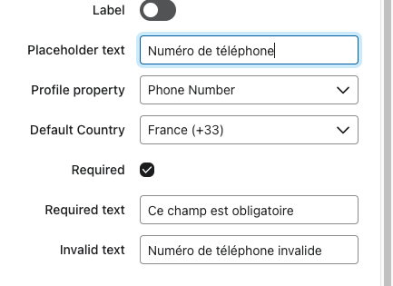
You can also choose to submit some hidden fields with the forms which will allow you to identify the users language/market.

If you have installed the code snippet referenced previously, Klaviyo will automatically record the relevant market profile properties on the next page load, but it’s no harm to manually set them as well once the form is submitted.

Make sure you use the same profile property field names to keep it consistent
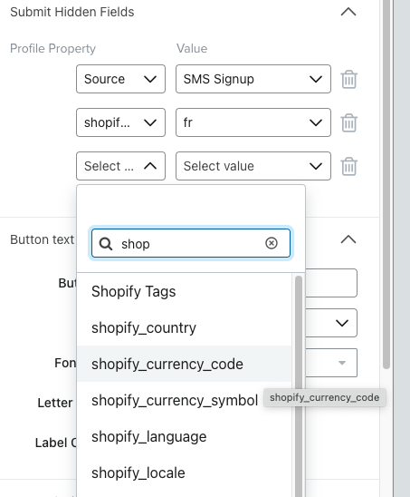

Reporting
When creating reports, you can utilize the shopify market related profile properties that you added to profiles.

You can filter and group by any of these properties when creating single and multi-metric reports
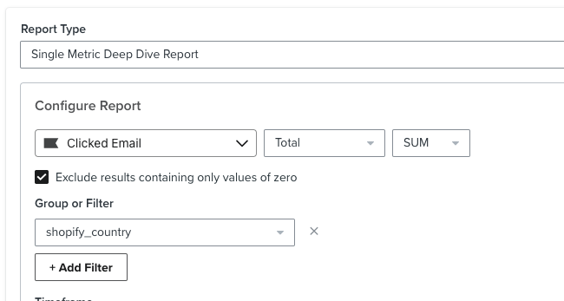
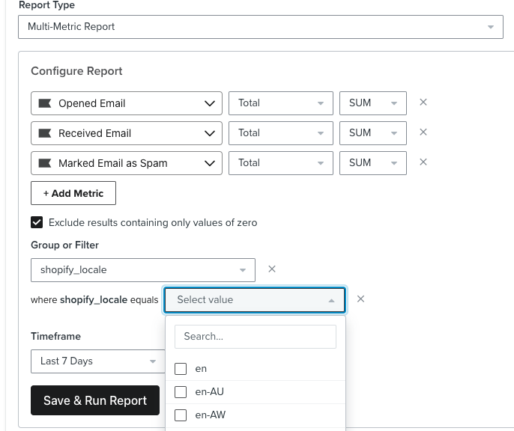

Depending how you are managing your flows and campaigns, you can also utilize the “tags” feature to group together different flows and campaigns per market
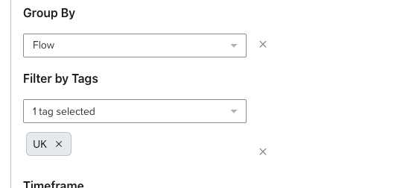

Migrating From Multiple Shopify Accounts to a Single Shopify Markets enabled account
You may currently be operating multiple different Shopify accounts, which are linked to a separate Klaviyo account.

Migrating to Shopify markets means you need to consolidate all of those Shopify accounts into one single account, which will also correspond to just a single Klaviyo account.

There are a number of factors that need to be considered to help with the migration, it is recommended that you start with a new Shopify Markets enabled account and integrate this with a new Klaviyo account.

Migrating Order Data
Shopify allows you to bulk export and import order data via CSV imports. You will move the order data into one single Shopify account.

When you connect your new Shopify Markets enabled store with Klaviyo, Klaviyo will automatically synchronise the last 10 years of order data from your store.

If you have integrated Klaviyo before you imported all of the order data, you can force a re-sync of the historical data clicking the “Re-Import” button on the integration settings in Klaviyo

https://www.klaviyo.com/integration/shopify

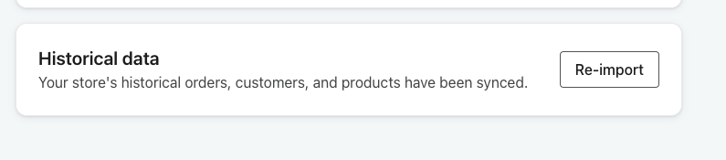

Migrating Profiles
Klaviyo will automatically create profiles from the historical sync with Shopify, but it is likely that you have additional profiles in your Klaviyo accounts that do not exist in Shopify.

To import the profiles from each of your Klaviyo accounts, create a segment of all your profiles and export the segment. Make sure you select all the profile properties you want to export, especially the last open and last click dates.
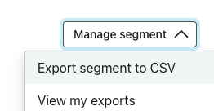

Important: before importing these profiles into Klaviyo, you should open up the CSV in Excel/Google Sheets and add some columns to indicate the profiles language and market information.

You should follow the naming convention used earlier in this document.

Here we’ve added “shopify_country”, “shopify_language” etc.. to our spreadsheet.
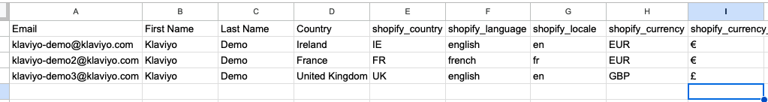
Each CSV file will likely contain just one market of profiles so the values will be the same for everyone in the CSV. Different examples are shown here for illustrative purposes

You can then import these into your new Klaviyo account that is integrated with your Markets enabled Shopify store. Klaviyo will automatically merge and de-duplicated these profiles.

Migrating Engagement Data
It is not possible to migrate or transfer email engagement data between your Klaviyo accounts. This is an important factor that needs to be considered when you are planning the timing of your migration.

As reference earlier, when exporting your data from the separate Klaviyo accounts, make sure you include the “Last Open” and “Last Click” email fields, these will then be saved as profile properties in the new account, and can be used for segmentation purposes.

You will then be able to use this data when creating segments as you build up your engagement history again
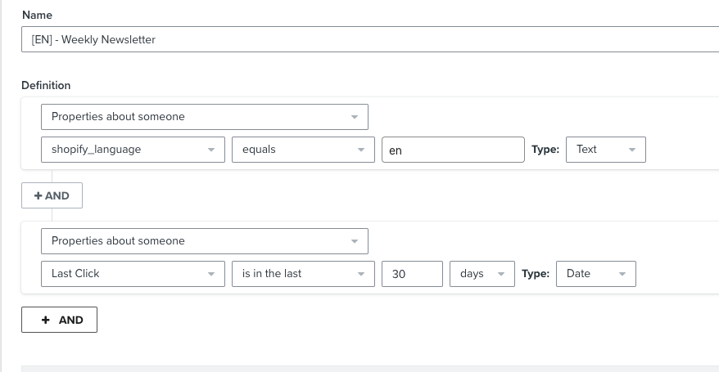

Migrate Suppressions
It is important to make sure you also migrate all the suppressions from each of your Klaviyo accounts into your new Klaviyo - Markets account.

Navigate to Profiles -> Suppressed Profiles https://www.klaviyo.com/people/suppressed and export this list to a CSV in each of your Klaviyo accounts.
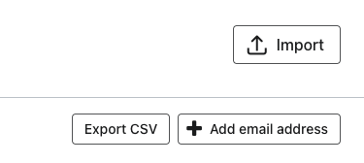
You will then import all of these into the suppressed profiles section of your Klaviyo - Markets account.

Important: You should do this after you have imported the lists from all of your other Klaviyo accounts, as the import process will lift any suppressions.

Migrating any other events
If there are any other custom events or third party integrations, these will need to be modified to send data to your new Klaviyo - Markets account.

It is not possible to migrate the events from one Klaviyo account to another, so you will need to backfill the events.

For events using our API, you can use the “time” property to back-date events
https://developers.klaviyo.com/en/reference/create_event

Migrating Flows
There can be challenges with date triggered flows. For example first order anniversary flows rely on the first purchase date to trigger and can’t be back populated.

A solution to this is to modify your date triggered flow to be “annual” but only allow profiles into it once (with a flow filter).

You then also add a conditional split of the date the flow went live, so that any pre-existing flows which qualify receive the email and everyone else waits a year.

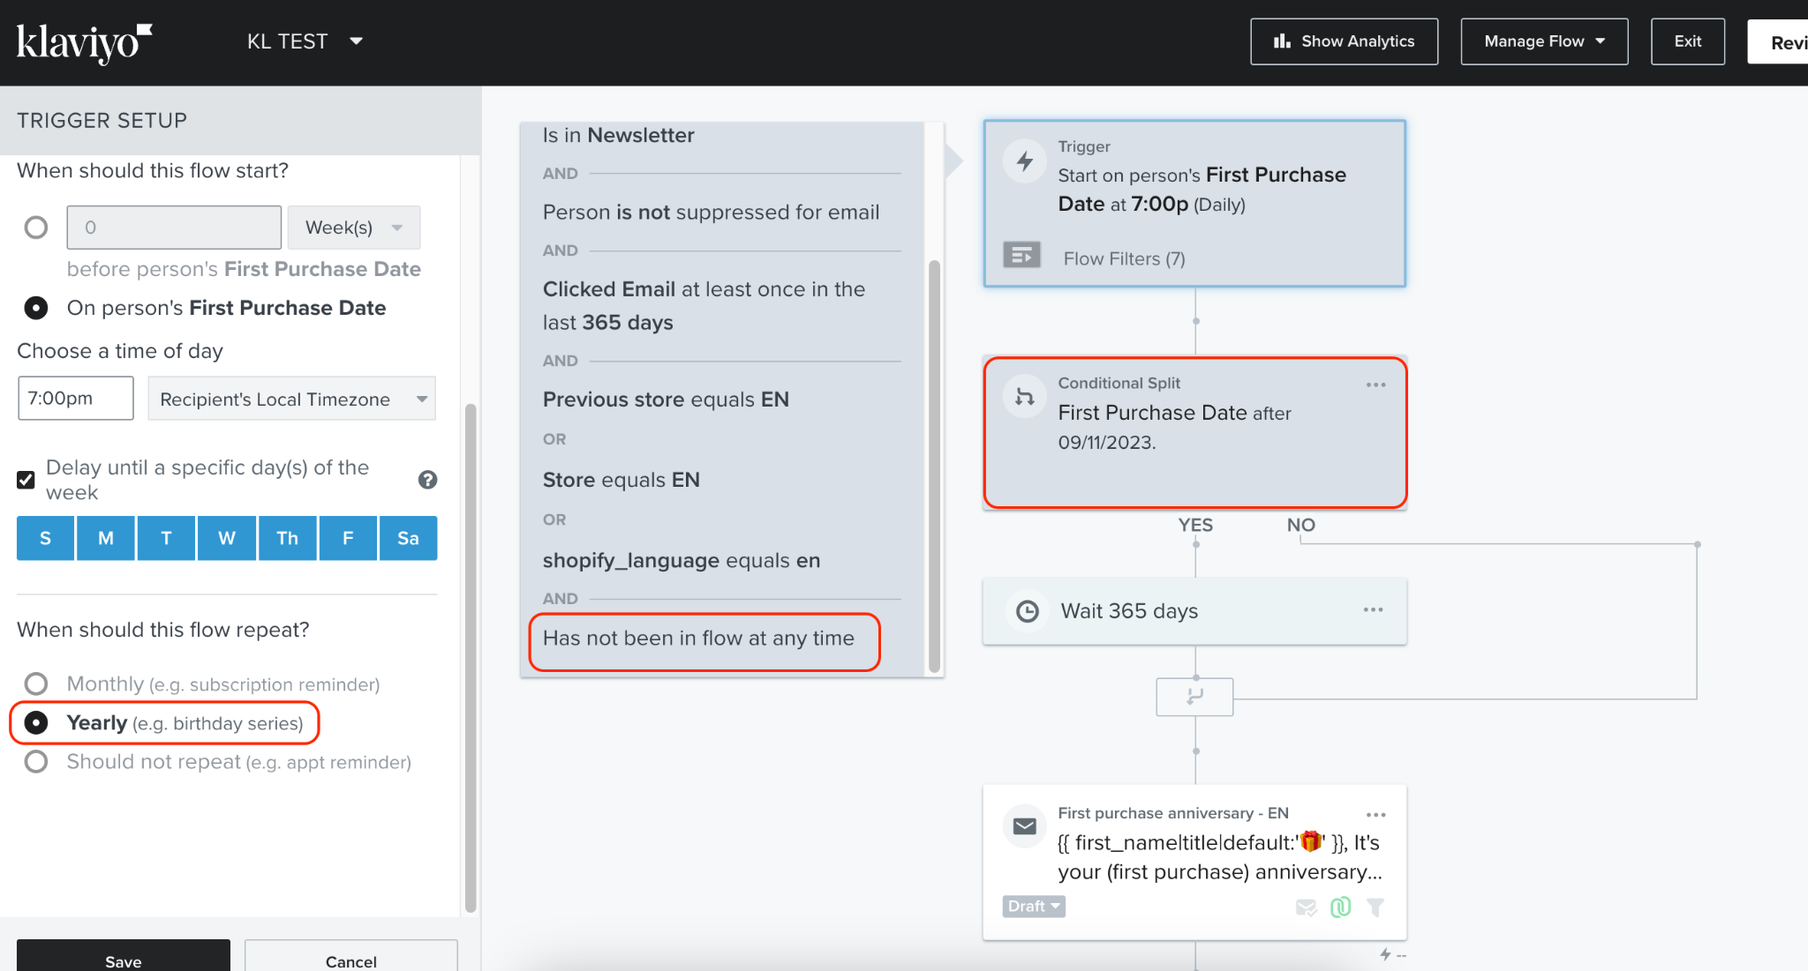

Sending Domains and Deliverability
When consolidating from multiple Klaviyo accounts to a single one as part of your markets migration, it’s important to take note of the sending domain you have been using.

If you have been using the Klaviyo shared domain, you do not need to worry about this.

Sending domain
If you have been using the same subdomain across all your Klaviyo account (ie. send.mydomain.com) then make sure you use this subdomain again on your new Klaviyo account.

If you have been using multiple different sending domains, it is recommended that you use the one that has the highest volume on your new account in order to preserve your reputation and remove the need for rewarming.

IP Address and IP Pools
If you created your Klaviyo accounts at different times, there is a strong likelihood that they are using different IP addresses for sending emails. You want to ensure that your new Klaviyo - Markets account is using the same IP address pool as your highest send volume account.

Klaviyo support or your CSM can ensure the IP pools are aligned and migrated for you.

If you have a static IP address assigned to your accounts, contact support to ensure this also gets assigned to your markets account.

Splitting Shopify Markets into separate Klaviyo Accounts
If you do not wish to use one single Klaviyo account for your Shopify Markets account, then you will need to perform a custom integration.

https://developers.klaviyo.com/en/docs/guide_to_integrating_a_platform_without_a_pre_built_klaviyo_integration

The Klaviyo x Shopify integration does not support integrating with multiple Klaviyo accounts at the same time.

Backfilling Shopify Markets Profile information
If you have had Klaviyo integrated with your Shopify Markets account for some time, but did not add the code snippets needed to capture market information, then you likely have a lot of profiles with no market information.

Shopify does not have a way to allow you to export this market information via a CSV.

The simplest way to backfill this information in Klaviyo is to create segments of profiles that match the markets based on the information we know about them. For example their country (which comes from the billing address field in Shopify)

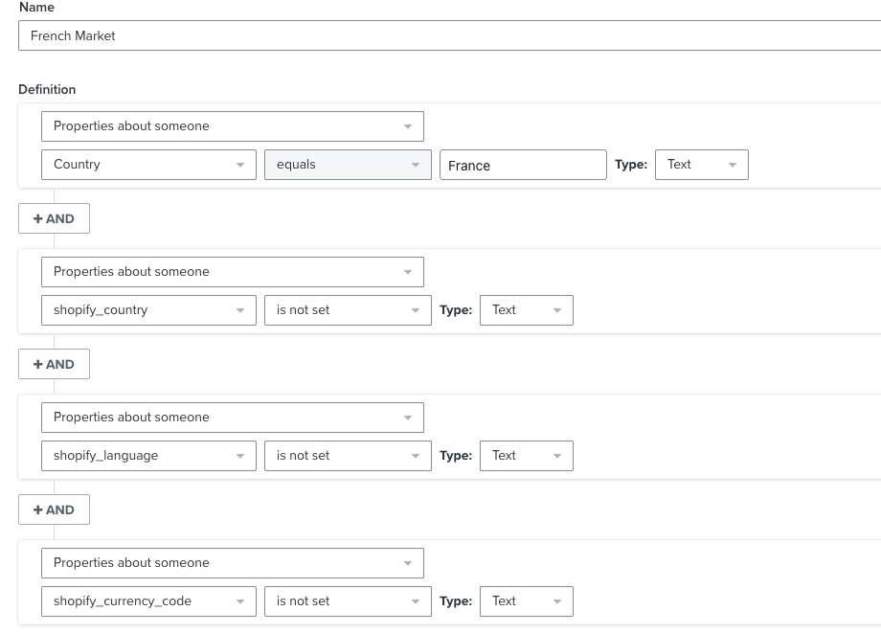
We can create a segment of this information, and then use it to power a flow that adds the profile properties

This can be a useful flow to keep on to always populate “default” market information for profiles that might be missing it for whatever reason.
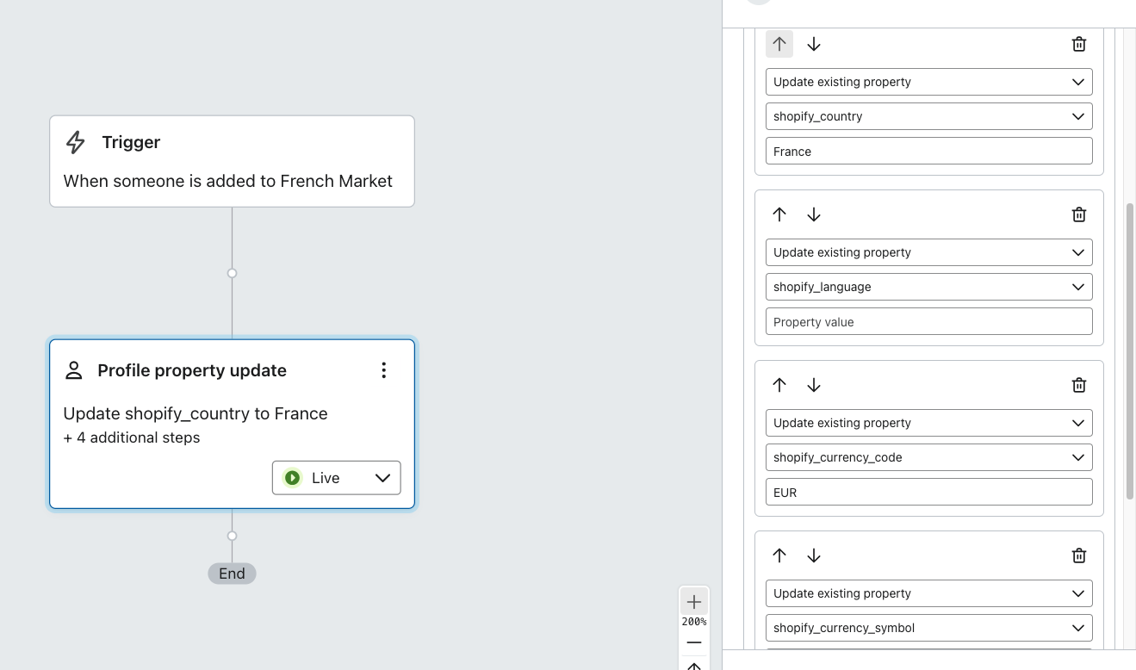

Common Integration Scenarios
While not usually an issue, it’s important to remember when migrating from Multiple Klaviyo accounts, to a single one, only 1 instance of a Klaviyo built integration can be added to an account at a time.

Shopify Markets x Reviews

Reviews can be implemented in the standard way as outlined in the help centre documentation found here

The form which the user leaves the review on is able to be translated into a specific user language and additional questions on the form can be set in

Reviews can be gathered in various languages, as they are inputs from end users. However, by default, reviews will be displayed in the language they were originally written in and won't automatically translate with the Shopify market page translation. Furthermore, the review module itself will maintain a base language of English.

For instance:
